1. 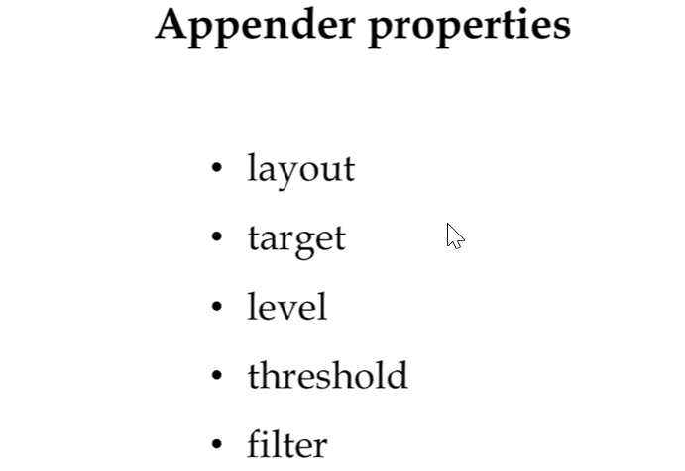
2. Apache log4J provides appenders object which are primarily responsible to print logging messages to different destinations (File, Socket, Event Log etc.)
3. Appender object has **different properties** such as
   1. **Layout**: Appender object takes a layout object and **conversion pattern** associated with Layout to format the logging info.
   2. **Target**: It could be console, file or something else.
   3. **Level**: Required to control the filtration of the log messages.
   4. **Threshold**: Appenders could have **threshold level** independent of **logger level**.   
      Appenders ignore any logging messages that have a level lower than threshold level.
   5. **Filter**: Filter object can analyze the logging message beyond level matching and decide whether logging requests should be handled by a particular appender or ignore.
4. 